

ISLAMIC UNIVERSITY OF TECHNOLOGY (IUT)
ORGANISATION OF ISLAMIC COOPERATION (OIC)
Department of Computer Science and Engineering (CSE)

QUIZ 1 STATISTICS

Average Breakdown

Problem |  | Average marks | Out of | Percentage
Unknown Base |  | 2.85 | 3 | 95.15%
Gray Code |  | 2.48 | 3 | 82.58%
Binary Arithmetic using (n–1)'s Complement |  | 2.19 | 6 | 36.44%
K–Map  (4 variable) | Build | 1.64 | 2 | 81.82%
 | Solve | 3.18 | 6 | 53.07%
Total |  | 12.22 | 20 | 61.11%

Attempts

Problem |  | Attempts | Out of
Unknown Base |  | 53 | 55
Gray Code |  | 52
Binary Arithmetic using (n–1)'s Complement |  | 47
K–Map  (4 variable) | Build | 49
 | Solve | 44

Performance Graph

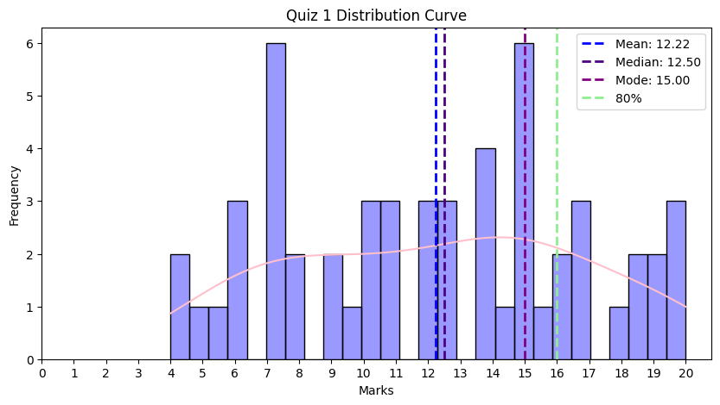

Leaderboard

Serial | ID | Name | Marks
1 | 230042152 | Mohammad Faiaj Jarif | 20
2 | 230042125 | Ittesaf Yeasir Ithun | 19.75
3 | 230042110 | S. M. Samiul Hossain | 19.5
4 | 230042104 | S.m. Tahsinuzzaman Emon | 19.25
5 | 230042144 | Nafian Nazat Mahid | 19
6 | 230042136 | Tahmid Hafiz | 18.5
7 | 230042139 | Sayma Tasnim | 18.5
8 | 230042106 | Md. Saif-al Sarker | 18

Unnecessary Statistics
- 1 student got a perfect score.
- 33 out of 55 students were able to build the K-map correctly, only 9 of them got everything right in Question 4.
- Only one out of 53 students who attempted Question 1 did not receive full marks.
- Out of the 52 students who attempted Question 2, 37 received full marks.
- The lowest average was in Question 4, which was less than half.
- Bonus –
  - If you attended the quiz and you didn’t get 0 → bonus 0.25 attendance mark.
  - If you attended the quiz and got more than the class average → bonus 0.5 attendance mark.
  - If you attended the quiz and got more than 80% marks (16) → bonus 1 attendance mark.

Few Things to be noted
- Questions 1 and 2 are relatively easy and straightforward. That said, please show a few steps instead of writing just the final answer. It's important to demonstrate how you arrived at the solution, otherwise, it's hard to tell whether the work is your own. For this quiz, I’ve given you the benefit of the doubt.
- Since you're just getting started with Karnaugh Maps (K-Maps), it’s okay to write the minterm values (m₀,m₁, etc.) inside the boxes. However, if you clutter the map with unnecessary information, you may find it difficult to group terms properly later. It’s better to keep it clean to avoid confusion.
- You’ve been taught three methods of simplification: Cut and Try, K-Map, and the Tabular Method. Once you derive an expression using any one of these methods, you should not apply another method to simplify it further. If additional simplification seems possible, that usually indicates your original simplification was incorrect or inefficient.

